Charry Bea Delos Santos

DCET 3-1

EMERGING TECHNOLOGY

Using:

GIT COMMANDS/INTRODUCE YOURSELF TO GIT

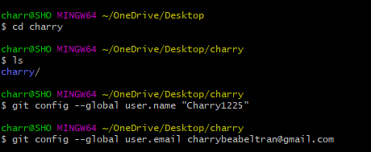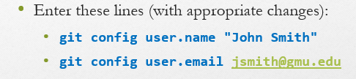

ADD MULTIPLE FILES, COMMIT AND STATUS

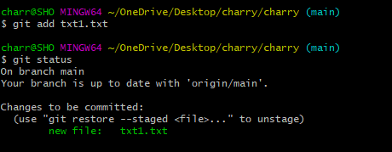

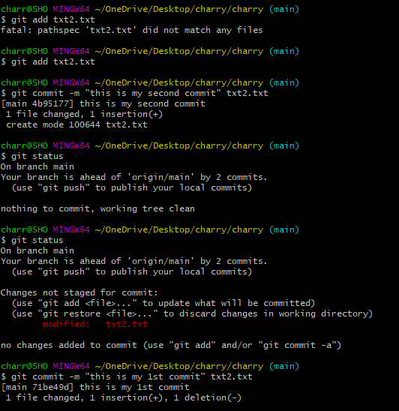



GIT CLONE

GIT DIFF

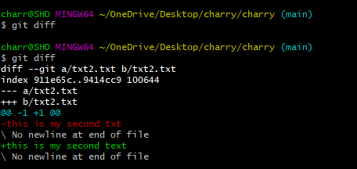

GIT HELP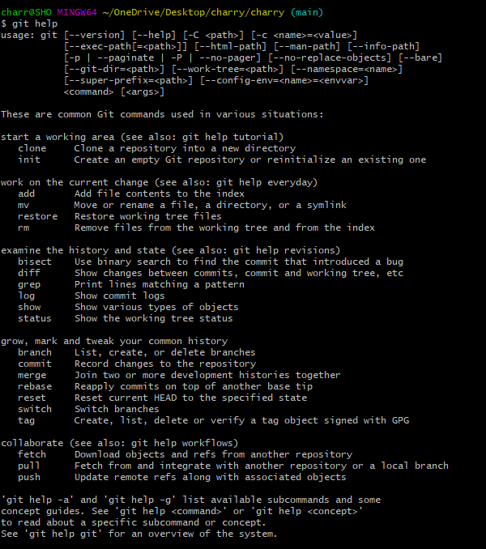

GIT PUSH

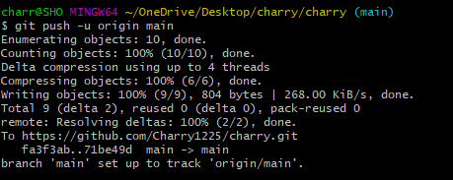

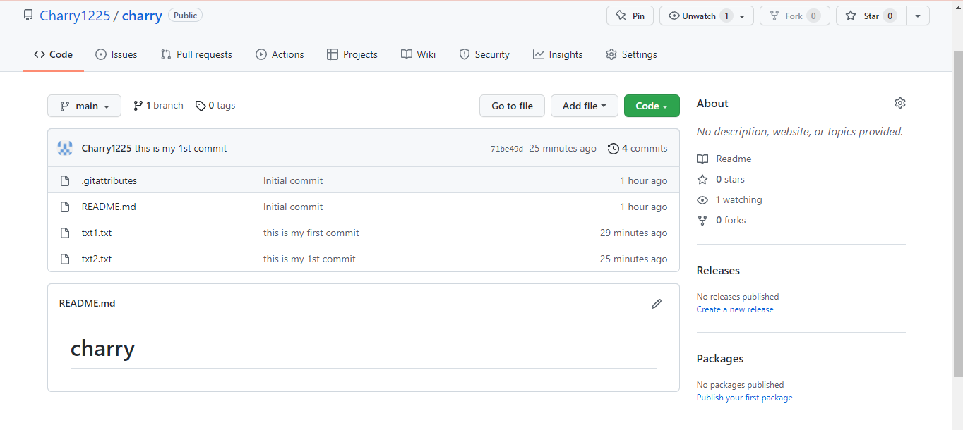

GIT PULL



GIT LOG

